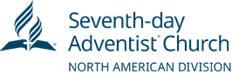

**North American Division**

**Office of Education**

9705 Patuxent Woods Drive

Columbia, MD 21046

Ph.: 443-391-7280

Fax: 443-259-4887

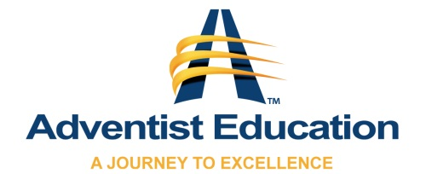

Teachers’ and Students’ Digitized Records

When transitioning from paper to digitized records, the Office of Education of the North American Division of Seventh-day Adventists in consultation with the Office of General Council, recommends that unions and conferences adhere to the following guidelines as it relates to the retention of teachers’ and students’ records.

Digitized records stored in a format that cannot be altered are legal documents, adequate for retention. Once paper records have been properly digitized, the paper records can be destroyed.

The length of time student records must be retained will vary, based on jurisdiction. Therefore, it is recommended that schools refer to their applicable state law regarding retention periods.